Дата: 14.03.2025

Клас: 7-А

Предмет: англійська мова

Тема: Діагностувальна робота за модулем «Natural Disasters».

Мета: : формувати навички вживання лексичних одиниць по темі; удосконалювати навички читання, аудіювання й усного монологічного мовлення; розвивати пізнавальні інтереси учнів; виховувати інтерес до самостійного пошуку потрібної інформації, а також загальну культуру учнів.

Вчитель: Руда Д.В.

Хід уроку

1.Greeting

Good afternoon, guys! I’m tickled pink to see you. Are you ready to start our lesson? All set?

Let`s get down to business.

2. Wаrm up / Listening

Уважно слухати аудіо трек і дати відповідь на питання вчителя <https://www.youtube.com/watch?v=Uk1dNJ_yh9o> .

3. Повторення

*Sleet-мокрий сніг(сліт)*

*Snowflake-сніжинка(сноуфлейк)*

*Blizzard-хуртелиця (блізард)*

*Mild: moderate in temperature; neither hot nor cold- помірний, м’який (майлд)*

*"Every cloud has a silver lining": every bad situation has some positive aspect to it. (e.g., "I lost my job, but I found a better one soon after. Every cloud has a silver lining.")- нема лиха без добра( ідіома)*

*To expect-очікувати(експект)*

*To report-повідомити(ріпот)*

*Chilly-прохолодний(чілі)*

*To get cold-холоднішати*

*It`s raining cats and dogs-сильно дощити (ідіома)*

*They cancelled the football game because it was raining cats and dogs.*

*puddle-калюжа (падл)*

*precipitation-опади (прісіпітейшн)*

*partly cloudy- мінлива хмарність (патлі клауді)*

*to be below freezing- бути нижче нуля*

*bitterly cold- дуже холодно*

.

*To pollute-забруднювати*

*To recycle-переробляти*

*A leaflet-листівка*

*To predict-передбачати*

*A recycling bin-контейнер для сміття*

*To prevent- запобігати*

4. Speaking

Дати усно відповіді на питання :

Do you have enough free time?

Do you have free time on Sundays?

Do you have much free time during the day?

Do you have much free time in the evenings?

Do you have much free time in the mornings?

Do you like to watch movies? (...like to play tennis, ...)

What are you doing this weekend?

What did you do last summer vacation?

What did you do last weekend?

What do you do in your free time?

What hobbies do you have?

When do you have free time? (How do you spend your free time?)

Where do you spend your free time?

Who do you spend your free time with?

How do you like to spend your free time?

going shopping? going to the cinema? chatting? playing computer games going to the disco? playing sports?reading? relaxing?

If you had more free time, what would you do with it?

Tell me about some good places to hang out.

Why are they good?

5. Writing

Виконати вправу подану нижче. (повторення словника та умовних речень)

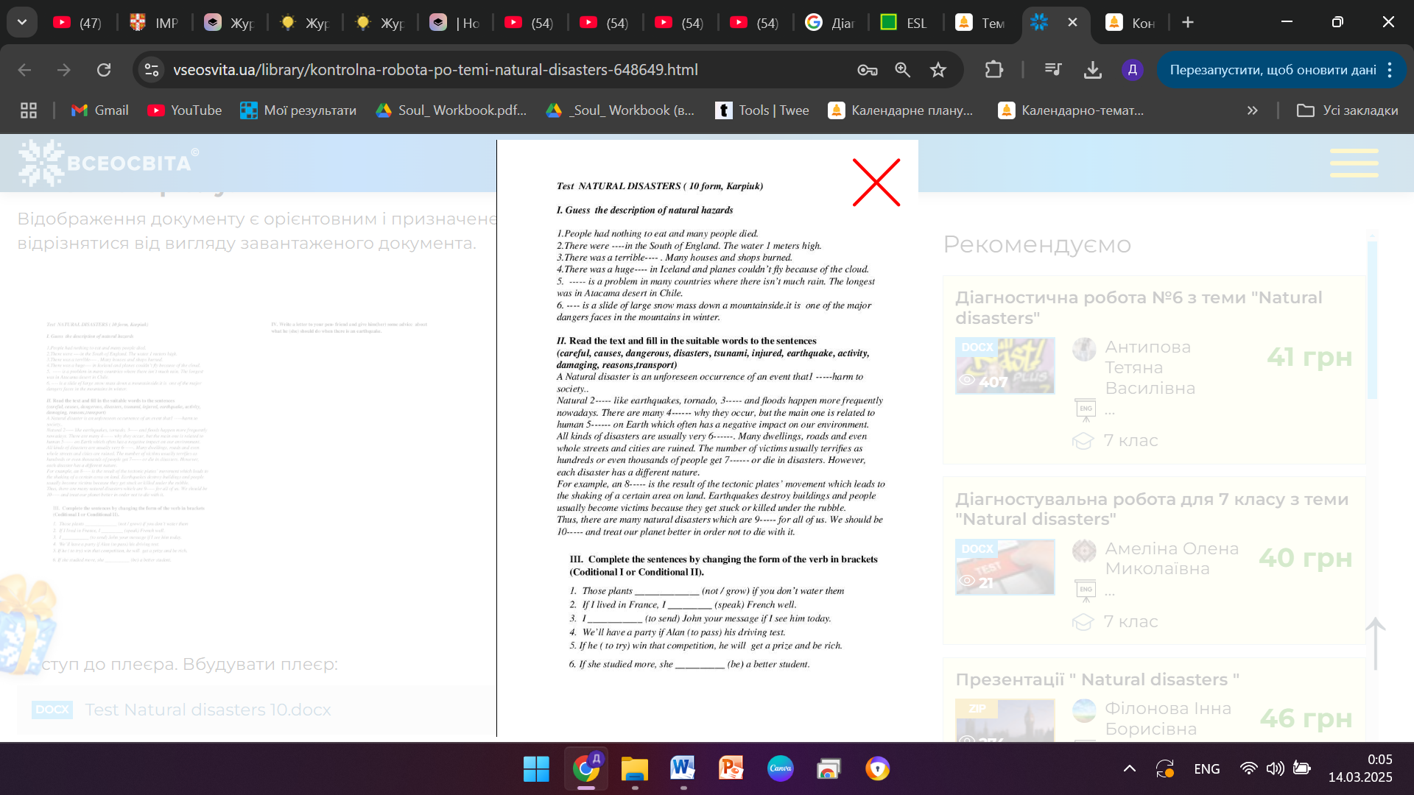

6. Vocabulary

*rely on-залежати від (рілай он)*

*reuse-повторно використати (ріюз)*

*self-sufficient-самодостатній (селф сафішинт)*

*throw away-викинути (сроу евей)*

*renewable- відновлюючий (рінюейбл) a renewable [energy](https://dictionary.cambridge.org/dictionary/english-russian/energy" \o "energy) [source](https://dictionary.cambridge.org/dictionary/english-russian/source" \o "source) such as [wind](https://dictionary.cambridge.org/dictionary/english-russian/wind" \o "wind) [power](https://dictionary.cambridge.org/dictionary/english-russian/power" \o "power)*

*Oil spill-розлив нафти*

*Plant-рослина*

*Government-уряд*

*To do an experiment-робити експеремент*

*To destroy-руйнувати*

*To increase - збільшувати*

7. Homework

1. Виконати письмово контрольну роботу .

**Control Work**

**I. Name what natural disaster it is.**

1. It is the shaking of the surface of the Earth. It can be extremely violent. They are caused by sudden movements of the Earth's tectonic plates.

2. It can be giant waves caused by earthquakes or volcanic eruptions under the sea.

3. It is a natural disaster of below-average precipitation in a given region, resulting in prolonged shortages in the water supply.

4. It is a violent rotating column of air extending from a thunderstorm to the ground. They are capable of tremendous destruction with wind speeds of up to 300 mph. They can destroy large buildings, uproot trees and hurl vehicles hundreds of yards.

5. It is the movement of rock, earth, or debris down a sloped section of land. They are caused by rain, earthquakes, volcanoes, or other factors that make the slope unstable.

**II. Complete the sentences with *cause* or *reason.***

1. The … of the fire was the lightning.
2. Speeding is often the … of car accidents.
3. I don't see any … why you can't come with us.
4. The … for his absence is his illness.
5. The floods are usually … of the infections.

**III. Complete the sentences using *Conditional I* or *Conditional II.***

1. If she  a new washing machine, she  less money in the laundromat. (buy/spend)

2. Please,  Louise to meet me in the restaurant if you  her. (tell/see)

3. If you  water, it  into ice. (freeze/turn)

4. If you  the car, the alarm  off. (touch/go)

5. If you don't , I  the police. (leave/call)

6. If it , we  home. (rain/stay)

7. He  the test if he . (pass/study)

8. She  to sell the car if she doesn't  a job. (have/find)